4500 West Lee Boulevard Lawton, Oklahoma 73505 580-250-5500

Application for Admission
Paramedic Program
Updated for 2024/2025
Completed Application Deadline: June 3, 2024

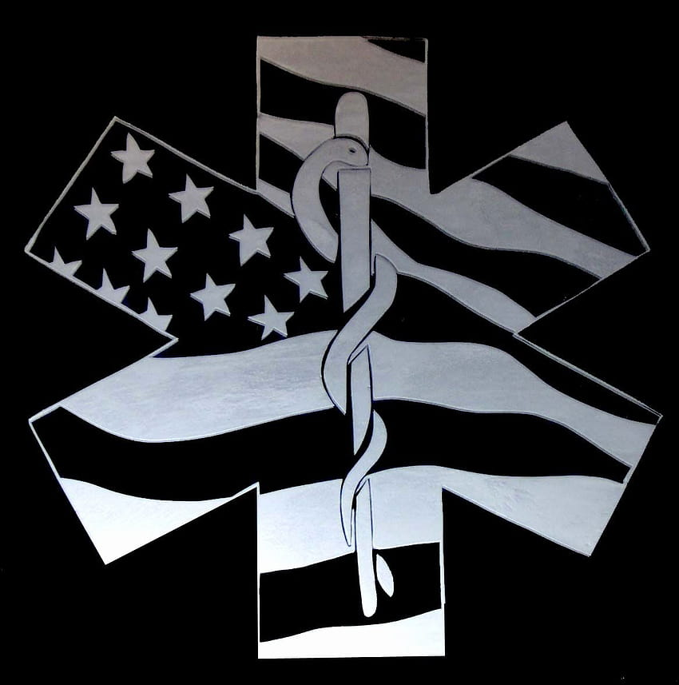

See Tech Tab for Start Dates
Accreditation Statement
GREAT PLAINS TECHNOLOGY CENTER IS ACCRETITED THROUGH STATE, REGIONAL, AND NATIONAL AGENCIES.

ALL FULL-TIME CAREER MAJORS/INSTITUTIONAL OFFERINGS ARE APPROVED BY

OKLAHOMA BOARD OF CAREER AND TECHNOLOGY EDUCATION

Oliver Hodge Building, Room 121
2500 North Lincoln Boulevard
Oklahoma City, Oklahoma 73105
405-521-3301

THE EMERGENCY MEDICAL SERVICES PROGRAMS ARE APPROVED BY:

Oklahoma State Department of Health
1000 Northeast Tenth Street
Oklahoma City, OK 73106
405.962.1800
http://health.state.ok.us

The Paramedic Training Program is accredited by:

Commission on Accreditation of Allied Health Education Programs
1361 Park Street
Clearwater, FL 33756
727-210-2350
http://www.caahep.org

Committee on Accreditation for the EMS Professions
8301 Lakeview Pkwy, Suite 111-312
Rowlett, TX 75088
214-703-8445
www.coaemsp.org

Other accrediting information for specific career majors is available upon request or may be viewed on the Great Plains Technology Center Website at http://www.greatplains.edu.
NOTICE OF NONDISCRIMINANTION
Great Plains Technology Center does not discriminate based on gender, gender expression, sexual orientation, gender identity, race or national origin, religion or because the employee or applicant is an individual with a qualified disability or is a qualified protected veteran.
It is the policy of Great Plains Technology Center to avoid discrimination against any employee or applicant for jobs because of the individual’s gender, gender expression, sexual orientation, gender identity, race, or national origin, or because the employee or applicant is an individual with a qualified disability or is a qualified protected veteran. Great Plains Technology Center will take affirmative action to employ all persons and promote all employees regardless of their gender, gender expression, sexual orientation, gender identity, race or national origin, religion or because the employee or applicant is an individual with a qualified disability or is a qualified protected veteran. Great Plains Technology Center will take affirmative action to employ all persons and promote all employees regardless of their gender, gender expression, sexual orientation, gender identity, race or national origin, religion or their having the status of a person with a disability or protected veteran. It is our policy to base all employment decisions on bona fide job qualifications. This policy applies not only to initial employment but also to all subsequent employment, compensation, and training actions at the school.
Employees and applicants at the school will not be subject to harassment, intimidation, threats, coercion, or discrimination because they have or may file a complaint against the school, assisted a regulatory agency in an investigation of the school, or exercised their rights under any federal, state, or local EEO laws.
The Administration and Board of Great Plains Technology Center is committed to the principles and goals of Affirmative Action and Equal Opportunity Employment. To ensure that these principles are carried out throughout the organization, the Superintendent has designated the Director of Adult Career Development as the administrator for implementation of the Affirmative Action Plan and organization-wide dissemination of AAP/EEO information.
Great Plains Technology Center has developed an Affirmative Action Plan which is available for review in the Superintendent’s office. Employees and/or applicants may review the plan upon request. All employees responsible for any part of the employee recruitment, employment, advancement, or compensation systems at the school will receive periodic training to ensure their understanding of the AAP and the school’s commitment to the principles of Affirmative Action and Equal Employment Opportunity of all individuals.
This notice is provided as required by Title VI of the Civil Rights Act of 1964, Section 504 and Section 503 of the Rehabilitation Act of 1973, Title IX of the Education Amendments of 1972, the Age Discrimination Act of 1975, and the Americans with Disabilities Act of 1990 Executive Order 12246, and the Vietnam Era Veterans’ Readjustment Assistance Act of 1974. Questions, complaints, or requests for additional information regarding these laws may be forwarded to the designated compliance coordinator(s) at Great Plains Technology Center, 4500 W. Lee, Lawton, OK 73505

Title IX Coordinators/Compliance Officers:
Lawton Campus:
Joelle Jolly
Valerie Anderson
Justin McNeil
580-355-6371

Welcome

Thank you for your interest in the Paramedic Program offered at Great Plains Technology Center. This training is offered through the Adult Career Development department and is intended to prepare students to successfully complete the NREMT– Paramedic certification examination. The goal of the training is to prepare competent entry-level Emergency Medical Technician – Paramedics in the cognitive (knowledge), psychomotor (skills), and affective (behavior) learning domains.

The Paramedic Program operates with a Program Director, a Medical Director, and the EMS Coordinator working as a team to ensure the training meets all state and national guidelines. All training activities are under the supervision of the Director of Instruction.

It is the prospective student’s responsibility to ensure that he or she meets all requirements listed in this application packet. The student is responsible for submitting all documentation required and meeting all the eligibility requirements by the application deadline. All applicants that have submitted all required documents by the deadline will be scheduled for an interview.

Once the Paramedic Program begins the students will progress through successful completion of required training while maintaining good enrollment standing through meeting grade and attendance requirements as well as financial obligations.

Great Plains Technology Center is committed to offering high-caliber educational opportunities to help each student reach his or her goals. If you have concerns to be addressed, contact personnel are as follows:

Linda Pledger Program Director 351-6764
Marcy Hobson EMS Coordinator 351-6762
Student Services Career Counselor 250-5535

Once again, thank you for your interest in Paramedic Program. Great Plains Technology Center will assist you in achieving your goals.

Paramedic PROGRAM Description

The Paramedic Program at Great Plains Technology Center consists of 749 classroom and lab hours. In addition, 392 clinical hours are required for successful completion of the paramedic program. Hours are subject to change according to changes in curriculum. All students must complete the application for admission and meet all prerequisite requirements as follows:

BLS-CPR Certification
EMT or AEMT Certification
Accuplacer Test
2 Professional References

The Paramedic Program begins with a foundation course addressing medical, legal, and ethical issues involved in the paramedicine profession. Additionally, students begin studies in pathophysiology, pharmacology, and medication administration. Students continue to more advanced studies of patient assessment, airway management, and ventilation, pulmonology, and trauma management. Students also learn advanced response techniques for medical, cardiac, psychiatric, and pediatric emergencies. Clinical hours will be required and will be performed in settings including emergency rooms, labor and delivery, pediatric, surgical, and critical care departments of hospitals as well as Advanced Life Support staffed ambulances.

Physical and Mental Requirements for Success

The Dictionary of Occupational Titles, published by the United States Department of Labor, rates the occupation of Paramedic as Strength Code V – Very Heavy Work. Abilities required to perform jobs rated V include:
- Exerting more than 100 pounds force occasionally and/or more than 50 pounds of force frequently, and/or more than 20 pounds of force constantly.
- These strength requirements exceed those of Heavy work

The Dictionary of Occupational Titles lists job tasks performed by Paramedics as follows:
- Administer life support care to sick and injured persons in a pre-hospital setting.
- Assess nature and extent of illness or injury to establish and prioritize medical procedures to be followed or need for additional assistance.
- Restores and stabilizes heart rhythm on pulseless, non-breathing patient, using a defibrillator.
- Initiates intravenous fluids for a variety of purposes, performs endotracheal intubation to open airways and ventilate patient.
- Administers injections of medications and drugs.
- Assists in extricating trapped victims and transports sick and injured persons to a treatment facility.
- Observes, records, and reports to physician patient’s condition and response to drugs, treatments, or other significant incidents.
- May drive mobile intensive care unit to scene.
- May serve as team leader for Emergency Medical Technicians.

The Dictionary of Occupational Titles has identified the academic skills for success in Paramedic Program. The following ratings are listed:
- Reasoning Development (R) – Level 4: Apply principles of rational systems to solve practical problems and deal with a variety of concrete variables in situation where only limited standardization exists. Interpret a variety of instructions furnished in written, oral, diagrammatic, or schedule forms.
- Mathematical Development (M) – Level 3: Calculate variables and formulas, monomials and polynomials, ratio and proportion variables, and percentages. Calculate surfaces, volumes, weights, and measures.
- Language Development (L) – Level 4: Read journals, manuals, dictionaries, thesauruses, encyclopedias, and other reference materials. Conversant in methods of speaking effectively in persuasive speaking, discussion, and debate.

TUITION, FEES AND BOOKS

Course | Hours | Tuition | Fees and Supplies | Books
Paramedic | ADT 509  ADL 240  Clinical Hours 392 | $2,869 | Clinical insurance, Background check, Platinum Planner/EMS Testing, HealthStream, ACLS, PALS, PHTLS certification cards and uniform polo shirts (2), tuition | Instructor will give the current book list out at orientation. Do not buy books prior to this.  Books are not included in tuition.
Totals | 1,141 | $2,869.00 | $331.00 | $765.00
Total: $3,965.00

Out of district tuition applies if student lives in an area that is not served by an area Technology Center. The out of district fee is two times the published price. Book prices are subject to change. Textbooks have been analyzed and have been determined to require a maximum grade 14.6 reading level.

PARAMEDIC UNIFORM AND SUPPLIES ESTIMATED COSTS
Uniform | Average Retail Price | Available From
EMT Uniform Pants (Black) | $50.00-70.00 | Various Medical Suppliers/Online
Black Duty Shoes | $75.00 - 200.00 | Various Medical Suppliers/Online
EMS Belt (Black) | $30.00 | Various Medical Suppliers/Online
Black Scrubs w/embroider | $35.00 | Various Medical Suppliers/Online
EMT Miscellaneous Tools | $200.00 | Various Medical Suppliers/Online
NOTE: PRICES ARE SUBJECT TO CHANGE. Ask if student discounts are available.

TESTING AND CERTIFICATION FEES RESPONSIBLE BY THE STUDENT
NREMT Cognitive Exam Fee | $160.00 | http://www.nremt.org
NREMT Psychomotor Skills Exam Fee | $310.00 | http://www.nremt.org
NOTE: PRICES ARE SUBJECT TO CHANGE. The Instructor will update you on the NREMT testing changes.
APPLICATION PROCEDURES

- Read this application packet completely.
- Complete the application for admission.
- Schedule for entrance assessments.
- Submit all required documentation to the ACD office. USE THIS CHECKLIST TO ENSURE YOU HAVE ALL REQUIRED DOCUMENTATION.
  - _____Copy of current EMT or AEMT Licensure
  - _____Copy of current BLS/CPR card
  - _____Two Professional Reference Requests (attached and submitted by individuals. Not the student)
  - _____Completed application
  - _____Current Accuplacer Test (within the last 6 months)
- When notified about acceptance, enroll at the Adult Career Development Office for Paramedic Level I. A CRIMINAL BACKGROUND CHECK WILL BE CONDUCTED UPON ENROLLMENT.

ASSESSMENTS

Great Plains Technology Center will require applicants to meet the admissions assessment requirements as outlined in the Great Plains Technology Center Policies and Procedures Manual. The standard assessment instrument in use at Great Plains Technology Center is the Accuplacer test. The fee is $10.00. Fees for missed testing appointments will be assessed according to Great Plains Policies. Please schedule this test with the ACD office at 580-250-5500. Let them know this is for the Paramedic Program application process.

REQUIRED DOCUMENTATION

NEGATIVE DRUG SCREEN

Students must complete a drug screen before they begin clinicals and before the date given by the instructor. Results must be forwarded to Great Plains Technology Center. The screen must be completed at:

MMG Occupational Health
3201 W Gore Blvd Suite G-1
Lawton, Oklahoma
(580) 355-9675

Fee for Screening: $45.00

*Negative Drug Screen results must be submitted by the deadline given by the instructor at the beginning of class.
VACCINATION VERIFICATION

Students must provide a vaccination record for the following vaccinations:
- Tdap or DTaP (Tetanus Vaccine)
- Hepatitis B vaccine series or waiver
- Varicella
- Measles, Mumps, and Rubella (MMR)
- Flu Vaccine or waiver (waiver is specific to clinical site)
- COVID-19 Vaccine or waiver (waiver is specific to clinical site)
- Negative PPD or x-ray (deadline for this will be given by the instructor after the start of class.)
In cases where the student is unable to access vaccination records (MMR or varicella, etc), blood titers must be supplied as supporting evidence. Titers may be obtained at the MMG Occupational Health. Applicable waivers will be provided by the instructor after the start of class. These records must be submitted at the start of class.

PROFESSIONAL REFERENCE REQUESTS

Students will be asked to have two people provide references. These people should be associated with the applicant in a professional capacity. No family members may serve as references. The reference sheet should be mailed into Great Plains Technology Center directly at the following address:

Great Plains Technology Center
4500 West Lee Boulevard
Lawton, Oklahoma 73505
Attention: EMS Coordinator

PREREQUISITE COURSE(S) AND LICENSURES
- A copy of a current EMT or AEMT license must be provided for the file.
- A copy of a current Basic Life Support – CPR certification card must be provided for the file.

FINANCIAL AID

The Paramedic Program is not currently eligible for federal financial aid, including PELL grants, student loans, and Oklahoma Tuition Assistance Grants (OTAG). The following are available:

Financial Aid may be obtained through the following sources, if qualified:

GREAT PLAINS FOUNDATION SCHOLARSHIP

The scholarship is awarded by the Great Plains Foundation, a local, non-profit organization. Scholarships are awarded based on the financial need of the applicant and are designed to pay 25%-75% of the tuition only for each level to assist students enrolling at Great Plains Technology Center. Students may apply at any time, but the scholarship will not cover previous levels. Scholarship forms may be picked up in the ACD office, in the Student Office, Building 100, Room 111, or on the GPTC website.

Applications should be turned in within 30 days of tuition payment due date.

Students will need to complete the FAFSA to assess the need-based portion of the scholarship. If you have any questions, please contact the Financial Aid office at Great Plains Technology Center.

Financial Aid applications should be returned to the Financial Aid Office.

The following are other options for financial assistance if eligible:

ASSOCIATION OF SOUTH-CENTRAL OKLAHOMA GOVERNMENTS (ASCOG)
1703 South 11th Street, Lawton, Oklahoma (580) 248-000
Aid is available to qualified individuals.

BUREAU OF INDIAN AFFAIRS
Aid is available to enrolled members of Native American tribes under a variety of programs. Contact your tribe for further information.

OKLAHOMA VOCATIONAL REHABILITATION
1332 Northwest 53rd Street, Lawton, Oklahoma (580) 585-4200
Based on qualifying condition and approval.

VETERAN’S ADMINISTRATION BENEFITS
Great Plains Technology Center Adult Career Development Career Counselor, if qualified.

PAYMENT PLAN POLICY

Great Plains payment plan policy will be reviewed at orientation with those students who have requested one at their initial interview.
SUPPORT SERVICES

CAREER COUNSELORS

Rhonda Mahaffey Career Counselor 580-250-5503
Amber Wilson Career Counselor 580-250-5539

CAREER ADVISOR

Hannah Ellis Career Advisor 580-250-5541

FINANCIAL AID

Rhonda Mahaffey ACD Veteran’s Benefits 580-250-5503
Dustin Davidson Financial Aid/VA Coordinator 580-250-5534

ACADEMIC ASSISTANCE

Mandee Thomas Academic Center Coordinator 580-250-5529

EMPLOYMENT ASSISTANCE

Chesley Graham Employment Advisor 580-250-5684

SPECIAL NEEDS ASSISTANCE

Kristy Barnett Disability Services Coordinator 580-250-5531

ADVANCED STANDING

Students who leave the Paramedic Program are only eligible to return at the beginning of the level that was incomplete, or the level decided upon by the Program Director, and only during the following course. Advanced Standing and credit will only be given for one year. Students applying for advanced standing from another program will be addressed on a case-by-case basis. The Program Director and/or Medical Director must approve returning students and Advanced Standing students.

RETENTION AND COMPLETION REQUIREMENTS

Students must maintain satisfactory attendance, acceptable grade point average, clinical performance standards, and tuition good standing to be retained in the Paramedic Program. Acceptable attendance, grades, and clinical performance standards are defined in the syllabus for each level of the program.

Office Use Accuplacer Results
Math: ___________
Reading: ___________
APPLICATION FOR ADMISSION
PARAMEDIC

PERSONAL INFORMATION- Answer each question legibly and completely.
Name ________________________________________ SSN _____________________________
Address ________________________________________ Email _____________________________
City, State, Zip ________________________________________ Date of Birth ________________________
Phone ________________________________________
Are you a registered sex offender? ______YES ______NO

EDUCATION INFORMATION
High school graduate or GED? ______YES ______NO

EDUCATION HISTORY-List all colleges and technical schools attended, and degrees/certificates obtained.
NAME OF INSTITUTION START DATE END DATE DEGREE/CERTIFICATE
__________________________________________________________________________________________
__________________________________________________________________________________________

Have you ever withdrawn or been dismissed from any full-time program at GPTC?
_______YES _______NO If yes, explain: ______________________________________________________

Previous GPTC Enrollment
PROGRAM YEAR HIGH SCHOOL OR ADULT?
__________________________________________________________________________________________
__________________________________________________________________________________________

EMPLOYMENT HISTORY
EMPLOYER START DATE END DATE
__________________________________________________________________________________________
__________________________________________________________________________________________
__________________________________________________________________________________________

By signing this application, you acknowledge that you have read and understood the information in this application.
Signature __________________________________________ Date ______________________________
THIS PAGE INTENTIONALLY LEFT BLANK
PROFESSIONAL REFERENCE REQUEST

RELEASE OF INFORMATION: I give my permission to release information to Great Plains Technology Center concerning my qualifications for entrance into the Paramedic Program. I agree to hold blameless the person being requested to complete and return this form.

Signature Date

CONFIDENTIAL RESPONSE FORM

GPTC Paramedic Program
Applicant Name (Printed) Program Applied For

Please complete the following form based on work association with the above applicant. Please complete all information requested below. Return the reference form by email or mail to:
Great Plains Technology Center
4500 West Lee Boulevard
Lawton, Oklahoma 73505
Attention: EMS Coordinator
EMAIL: mhobson@greatplains.edu

Please do not give this reference back to the applicant. It must be submitted directly to Great Plains Technology Center. Thank you for your assistance in this matter.

Please rate the applicant in each of the following areas:
Dimension/Trait | Exceeds Standard | Meets Standard | Below Standard
Judgment & Problem Resolution
Tolerance for Stress
Teamwork
Communication Skills
Attention to Detail/Organization
Initiative
Appropriate appearance and Demeanor
Accepts Criticism and Suggestions
Attendance and Punctuality

My acquaintance with the applicant has been as a:

- Employer/Supervisor
- School Advisor/Counselor
- Instructor/Professor/Teacher
- Professional Colleague/Coworker
- Physician
- Other______________________

Name Organization
Address
City, State, Zip Telephone/FAX
Signature Date

THIS PAGE INTENTIONALLY LEFT BLANK
PROFESSIONAL REFERENCE REQUEST

RELEASE OF INFORMATION: I give my permission to release information to Great Plains Technology Center concerning my qualifications for entrance into the Paramedic Program. I agree to hold blameless the person being requested to complete and return this form.

Signature Date

CONFIDENTIAL RESPONSE FORM

GPTC Paramedic Program
Applicant Name (Printed) Program Applied For

Please complete the following form based on work association with the above applicant. Please complete all information requested below. Return the reference form by email or mail to:
Great Plains Technology Center
4500 West Lee Boulevard
Lawton, Oklahoma 73505
Attention: EMS Coordinator
EMAIL: mhobson@greatplains.edu

Please do not give this reference back to the applicant. It must be submitted directly to Great Plains Technology Center. Thank you for your assistance in this matter.

Please rate the applicant in each of the following areas:
Dimension/Trait | Exceeds Standard | Meets Standard | Below Standard
Judgment & Problem Resolution
Tolerance for Stress
Teamwork
Communication Skills
Attention to Detail/Organization
Initiative
Appropriate appearance and Demeanor
Accepts Criticism and Suggestions
Attendance and Punctuality

My acquaintance with the applicant has been as a:

- Employer/Supervisor
- School Advisor/Counselor
- Instructor/Professor/Teacher
- Professional Colleague/Coworker
- Physician
- Other______________________

Name Organization
Address
City, State, Zip Telephone/FAX
Signature Date

